**Stats Lecture 3**

**Let’s Revise Everything**

**Random Variable**

Real Value of random experiment is called random variable

**Ex-1** Toss two coins simultaneously

S=sample space = {HH, HT, TH, TT}

Suppose we declared our R.V. as

X= Number of heads

X(HH)=2

X(HT)=1

X(TH)=1

X(TT)=0

So, x can take values like 2, 1, 0 if tossed two coins

X = {2,1,0} or real value

**HW**

**Ex-2 Throw a dice**

X= number of odd no.

S= {1,2,3,4,5,6}

**Where, Sample Space Real Values**

**X(1)=1 1**

**X(2)=0 2 0**

**X(3)=1 3**

**X(4)=0 4 1**

**X(5)=1 5**

**X(6)=0 6**

**Discrete Random Variable**

**Continues Random Variable**

Now Before Going to Further We should Know this

X🡪 Random Variable

P(X)🡪Probability Distribution

u or E(X) 🡪 Mean/ kind of Avg.

Var (X)🡪 Variance

6🡪 Std. Deviation

X : S 🡪 R

^ ^ ^

R.V Sample Real

Space Number

Real time Example

Tossing 2 Coins

S=sample space = {HH, HT, TH, TT}

Suppose we declared our R.V. as

**X= Number of heads – Number of Tails**

X(HH)= 2-0 = **2**

X(HT)= 1-1 = **0**

X(TH)= 1-1 = **0**

X(TT)= 0-2 = **-2**

X= {-2, 0, 2}

**Q1- Find the probability Distribution of the random variable**

**X or xi p(x) or pi X2 X2*pi**

**-2 ¼ 4 1**

**0 2/4 0 0**

**2 ¼ 4 1**

**=1 =2**

**Q2- Find Mean (u) or E(x)**

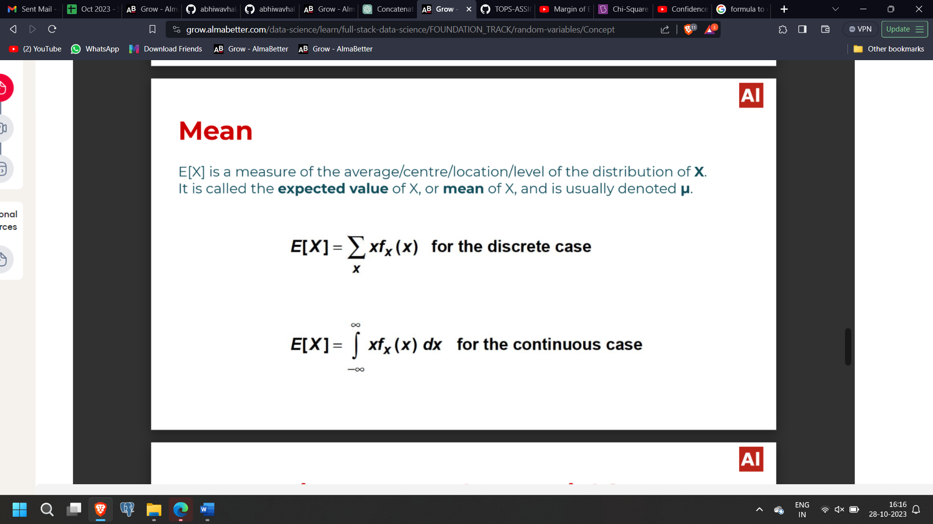

**u= (x1*p1) + (x3*p3) + (x1*p3)**

**u=0…… After Calculating**

**Another Example**

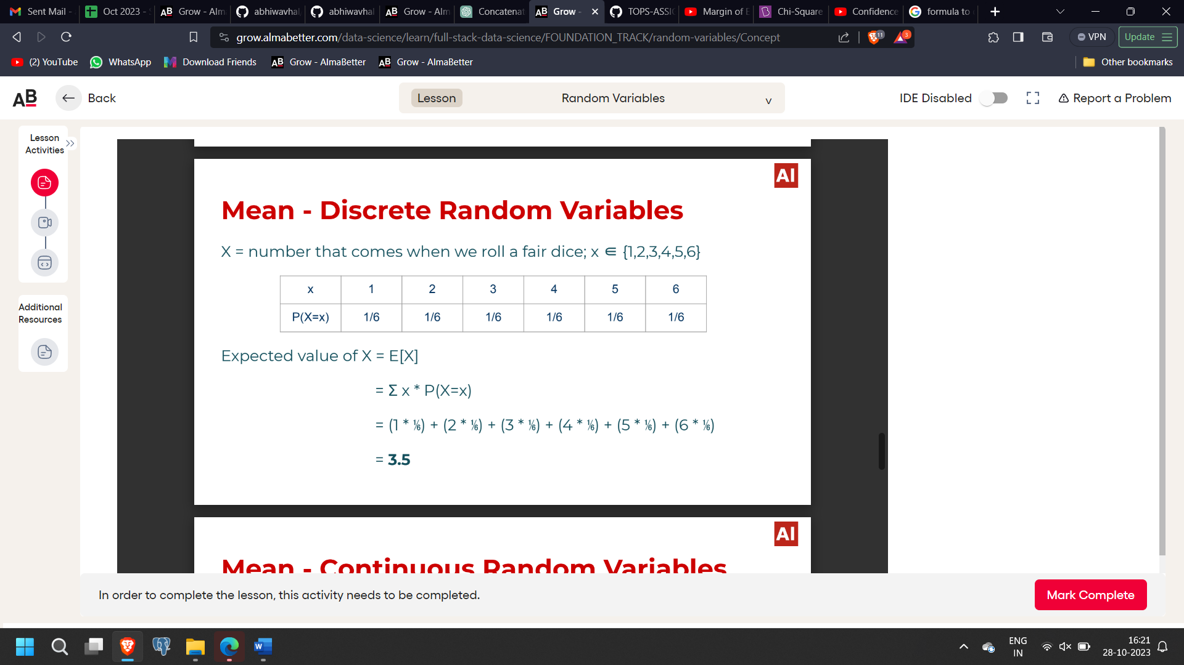

**Q3- Calculate Variance**

**The variance σ2 is a measure of the spread/ dispersion/ variability of the distribution. Specifically, it is a measure of the spread of the distribution about its mean.**

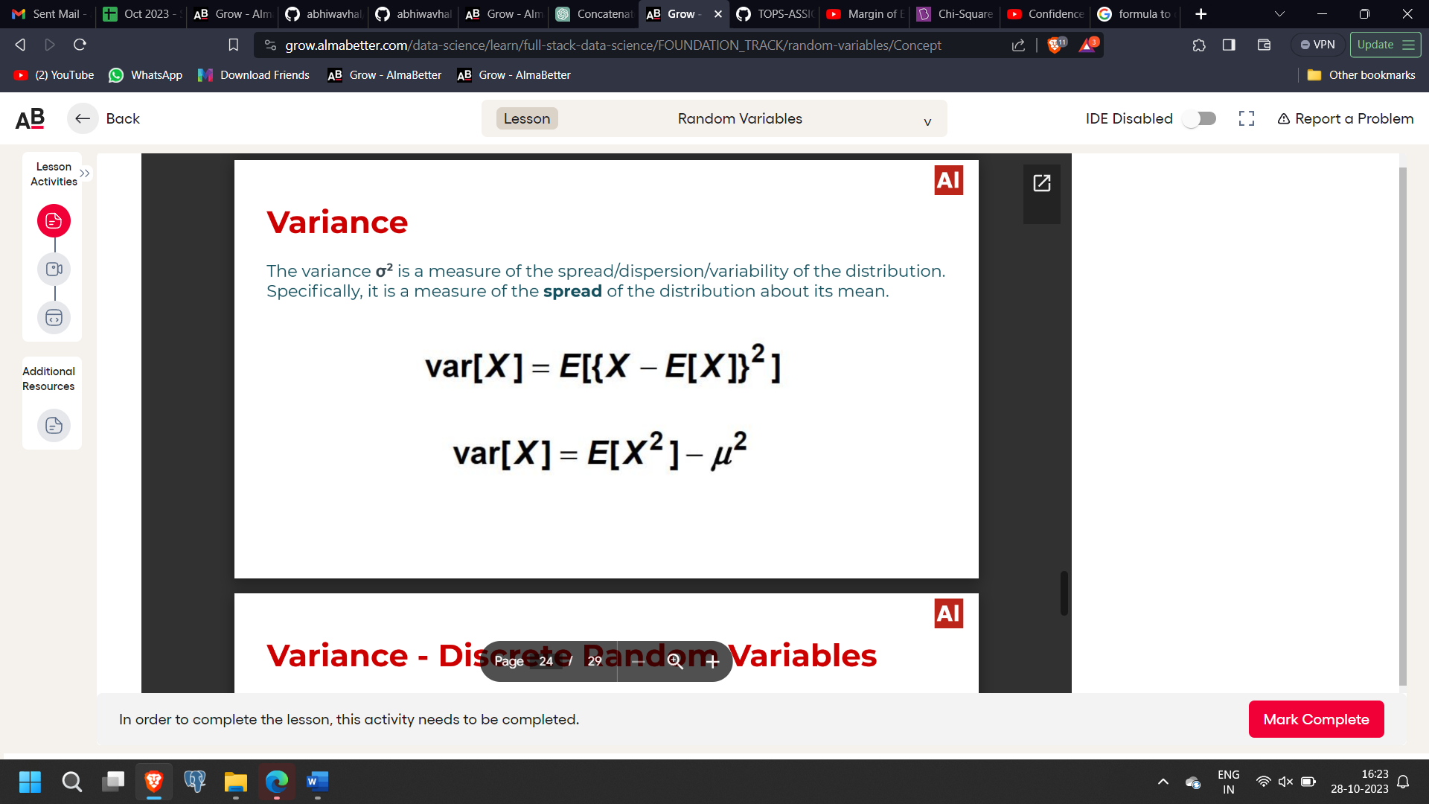

**Or**

**Var(X)= Summation of (xi2 . pi2) – u2**

**Var(X)= 2 – 0**

**Var(X)= 2**

**Where,**

**we know that from question 1 Summation of (xi2 . pi2)= 2**

**and u = 0**

**Std. deviation = root of Var(X)**

**Mean = we just saw i.e., Avg. Value**

**Median = Middle Value when arranged in ascending order**

**Mode = The value appeared most frequently**

**Variance = Closeness of bulk values**

**= Nearness of values towards average values**